


DESIGN AND VERIFICATION OF LOW POWER PERCEPTRON-BASED AI DECISION ENGINE

A PROJECT REPORT

Submitted by
MOHAMMED MOIENUDDIN ALI S A 61072212128
PACKYA MUTHUKUMAR M 61072212132
PRADEEP PALANISELVAM T 61072212136
VIGNESHKANNAN R 61072212157

In partial fulfilment for the award of the degree
of
BACHELOR OF ENGINEERING
In
ELECTRONICS AND COMMUNICATION ENGINEERING

GOVERNMENT COLLEGE OF ENGINEERING,
BARGUR (AUTONOMOUS)
KRISHNAGIRI-635104, TAMIL NADU.
(An Autonomous Institution and Affiliated to Anna University)
APRIL 2026
BONAFIDE CERTIFICATE

This is to certify that the project report entitled “DESIGN AND VERIFICATION OF LOW POWER PERCEPTRON-BASED AI DECISION ENGINE” is a Bonafide work done by the following students under my supervision and guidance.

MOHAMMED MOIENUDDIN ALI S A 61072212128
PACKYA MUTHUKUMAR M 61072212132
PRADEEP PALANISELVAM T 61072212136
VIGNESHKANNAN R 61072212157

SIGNATURE |  | SIGNATURE
Prof. J. NARGIS, M.E., |  |  | Dr. V. THIRUNAVUKKARASU, M.E., Ph.D.,
Project Supervisor  Assistant Professor  Department of Electronics and  Communication Engineering  Government College of Engineering  Bargur-635 104 |  | hbhbb | Professor & Head of the Department  Department of Electronics and  Communication Engineering  Government College of Engineering  Bargur-635 104

Submitted for the Project report viva voce Examination held on_______________

INTERNAL EXAMINER EXTERNAL EXAMINER
ACKNOWLEDGEMENT

I express my highest regards and sincere thanks to our esteemed Principal Dr. V. THIRUNAVUKKARASU, M.E., Ph.D., Professor and Head of the Department of Electronics and Communication Engineering, for his encouragement and support, which motivated me to undertake and complete this project successfully.
It was a matter of great privilege and pride to carry out this project work under esteemed guidance of Prof. J. NARGIS, M.E., Assistant Professor of Department of Electronics and Communication Engineering, whose constant encouragement and unwavering support have been instrumental in the completion of this project.
My sincere gratitude also goes to the faculty members and lab assistants for their continuous support in technical assistance given throughout the course of the project and extend my gratitude to my parents who helped to make this project a success.
Finally, it is indeed a great pleasure and privilege to acknowledge the help and support received from the positive minds around us, which have contributed significantly to the success of this endeavour.

ABSTRACT
The rapid growth of Artificial Intelligence (AI) applications has increased the demand for efficient hardware implementations capable of delivering high performance with low power consumption. Software-based AI models are often resource-intensive and unsuitable for real-time embedded systems. This project presents the design and simulation of a low-power AI decision engine using Verilog HDL, targeting FPGA-based systems. The proposed system is based on a single-layer perceptron model that performs decision-making using weighted inputs and a threshold-based activation function. The design is parameterized and currently supports eight input features represented in fixed-point format, reducing hardware complexity and power consumption compared to floating-point implementations. The design is functionally verified through simulation using testbench-driven validation. Results demonstrate correct real-time decision-making with efficient resource utilization. Although hardware implementation was not completed, the design is fully synthesizable and suitable for FPGA deployment, highlighting the potential of lightweight AI models in low-power hardware systems.
TABLE OF CONTENTS

CHAPTER NO. TITLES PAGE NO.

ABSTRACT

1. INTRODUCTION 1
1.1 PROBLEM STATEMENT
1.2 OBJECTIVES
1.3 SCOPE OF THE PROJECT
1.4 LITERATURE REVIEW

2. SYSTEM OVERVIEW 3
2.1 HIGH-LEVEL ARCHITECTURE
2.1.1 SOFTWARE PHASE
2.1.2 HARDWARE PHASE
2.2 DATA FLOW EXPLANATION
2.3 DESIGN CONSIDERATIONS
2.3.1 POWER OPTIMIZATION
2.3.2 SCALABILITY
3.3.3 MODULARITY

3. IMPLEMENTATION 9
3.1 INPUT FEATURE DESIGN
3.2 FIXED-POINT REPRESENTATION
3.3 AI MODEL REPRESENTATION
3.4 WEIGHT STORAGE & INITIALIZATION
3.5 COMPUTATIONAL BLOCKS
3.6 CONTROL LOGIC (FSM)
3.7 UART INTERFACE
3.8 TOP MODULE INTEGRATION

4. FUNCTIONAL SIMULATION 21
4.1 SIMULATION SETUP
4.2 TESTBENCH DESIGN
4.3 SIMULATION RESULTS

5. ANALYSIS 26
5.1 TIMING ANALYSIS
5.2 RESOURCE UTILIZATION ANALYSIS
5.3 POWER ANALYSIS
5.4 PERFORMANCE DISCUSSION
5.5 DISCUSSION ON DESIGN EFFICIENCY

6. LIMITATION & FUTURE WORK 30
6.1 LIMITATIONS OF THE PROPOSED SYSTEM
6.2 FUTURE WORK

7. CONCLUSION 32

REFERENCES 33

LIST OF FIGURES

FIG. NO. FIGURE PAGE NO.
2.1. AI DECISION ENGINE - BLOCK DIAGRAM 06
3.1. SIMPLE PERCEPTRON DIAGRAM 12
3.2. MAC BLOCK DIAGRAM 14
3.3. FSM STATE DIAGRAM 15
3.4. UART FRAME FORMAT DIAGRAM 19
3.5. TOP LEVEL BLOCK DIAGRAM 20
4.1. PROJECT SETUP 21
4.2. DESIGN SOURCE FILES INCLUDED 22
4.3. CLOCK TOGGLING 22
4.4. SIMULATION TOP LEVEL WAVEFORM 24
4.5. SIMULATION STATE WAVEFORM 25
4.6. SIMULATION TERMINAL OUTPUT 25
5.1. TIMING REPORT 26
5.2. UTILIZATION REPORT 27
5.3. POWER REPORT 28

LIST OF TABLES

TABLE. NO. TABLE PAGE NO.
3.1. INPUT FEATURES 09
3.2. SAMPLE TRAINED WEIGHTS USED IN DESIGN 13
3.3. STATE TRANSITION TABLE 17
4.1. TEST CASES TABLE 23

CHAPTER 1

INTRODUCTION
1.1 PROBLEM STATEMENT:
The rapid growth of Artificial Intelligence (AI) in embedded and real-time systems has created a need for efficient and low-power hardware implementations. Traditional AI models are typically executed on CPUs and GPUs, which consume high power and are not suitable for resource-constrained environments. Although FPGAs provide a promising platform due to their parallelism and flexibility, implementing AI algorithms in hardware introduces challenges such as high computational complexity and resource utilization. In particular, floating-point arithmetic used in software models is inefficient for hardware realization. There is also a need for scalable architectures that can adapt to different input configurations. Therefore, this project focuses on designing a low-power AI decision engine using a Perceptron model with fixed-point arithmetic and a parameterized architecture, implemented in Verilog and validated through simulation for FPGA-based applications
1.2 OBJECTIVES:
The main objective of this project is to design and simulate a low-power AI decision engine using Verilog HDL. The system aims to implement a Perceptron-based model capable of processing multiple input features efficiently using fixed-point arithmetic. Another objective is to develop a parameterized and scalable architecture that allows flexibility in design.
The project also focuses on integrating essential hardware modules such as MAC units, control logic, and communication interfaces. Finally, the design is verified through simulation to ensure correct functionality and readiness for FPGA deployment.
1.3 SCOPE OF THE PROJECT:
This project focuses on the design and functional simulation of a hardware-based AI decision engine targeting FPGA platforms. The scope includes implementing a Perceptron model using fixed-point arithmetic and developing modular components such as input handling, computation blocks, and control logic. The design is parameterized to support scalability in terms of input features. Simulation and verification are carried out using testbenches to validate system functionality. However, the project does not include physical FPGA implementation due to practical constraints, and performance evaluation is limited to simulation-based analysis.
1.4 LITERATURE REVIEW
Recent advancements in FPGA-based AI systems have demonstrated the potential for achieving high performance with reduced power consumption compared to traditional processors. Several studies highlight the use of simplified neural network models, such as Perceptron, for efficient hardware implementation. Fixed-point arithmetic has been widely adopted to minimize resource usage while maintaining acceptable accuracy. Researchers have also explored parameterized architectures to improve design flexibility and reusability. Additionally, techniques such as parallel processing and optimized MAC units are commonly used to enhance performance. These works collectively indicate that FPGA-based AI acceleration is a viable approach for low-power and real-time applications.

CHAPTER 2

SYSTEM OVERVIEW

2.1 HIGH-LEVEL ARCHITECTURE
The proposed system is a hardware-based AI decision engine designed using a Perceptron model and implemented in Verilog HDL for FPGA-based applications. At a high level, the system consists of several functional blocks including input feature acquisition, feature storage, weight storage, computational units, control logic, and output generation.
The system operates by accepting a set of input features, which are processed through a sequence of operations to generate a decision output. Each input feature is multiplied with a corresponding weight, and the results are accumulated using a Multiply-Accumulate (MAC) unit. The accumulated value is then passed through an activation function to determine the final output of the system.
A key aspect of the architecture is its parameterized design, which allows flexibility in configuring parameters such as the number of input features and data width. This makes the system scalable and adaptable to different AI applications without requiring major structural changes.
Overall, the design follows a modular approach where each functional block is independently designed and later integrated into a top module. This improves readability, maintainability, and ease of debugging. The architecture is optimized for FPGA implementation, ensuring efficient utilization of hardware resources while maintaining low power consumption.

2.1.1 SOFTWARE PHASE
The software phase plays a crucial role in preparing the necessary data and parameters for the hardware implementation of the AI model. In this phase, the structure of the Perceptron model is defined, including the number of input features and their corresponding weights.
The input data is first analysed and converted into a suitable format for hardware processing. Since hardware systems operate efficiently with fixed-point numbers, the input values are scaled and quantized into fixed-point representation. This ensures compatibility with the arithmetic operations used in the hardware design.
Weight values required for the Perceptron model are also determined during this phase. These weights can be manually defined or derived from training processes performed externally. Once determined, the weights are converted into fixed-point format and embedded into the hardware design.
Additionally, preprocessing steps such as normalization and data formatting are carried out to ensure consistent and accurate input representation. The processed data is then used as input stimuli during simulation through testbenches.
The software phase effectively reduces the complexity of the hardware design by handling tasks such as data preparation and parameter configuration outside the hardware environment. This separation improves design efficiency and simplifies debugging and validation
2.1.2 HARDWARE PHASE
The hardware phase involves the actual implementation of the AI decision engine using Verilog HDL. This phase translates the conceptual AI model into a functional digital system that can be synthesized and deployed on FPGA platforms.
The process begins with input acquisition, where feature data is received either through a UART interface or directly from a testbench. The received data is temporarily stored in feature registers, which act as buffers for further processing. The stored input features are then fed into the computational unit, which consists of a Multiply-Accumulate (MAC) block. In this block, each input feature is multiplied with its corresponding weight, and the results are accumulated to produce a final sum. This operation forms the core of the Perceptron model.
The accumulated result is passed through an activation function, which determines the final output of the system. The activation function is typically a simple threshold function that produces a binary output based on the computed value. A control unit implemented using a Finite State Machine (FSM) coordinates the entire operation. It controls when data is loaded, when computation begins, and when the output is generated. This ensures proper sequencing and synchronization between different modules.
The UART interface enables serial communication, allowing external systems to send input data to the hardware. The UART receiver converts serial data into parallel format suitable for internal processing.
Finally, all modules are integrated into a top-level design, ensuring seamless data flow and interaction between components. The complete system is verified using functional simulation to ensure correctness and reliability. The hardware phase emphasizes efficient design practices such as the use of fixed-point arithmetic, modular architecture, and optimized data flow, making the system suitable for low-power FPGA-based AI applications.

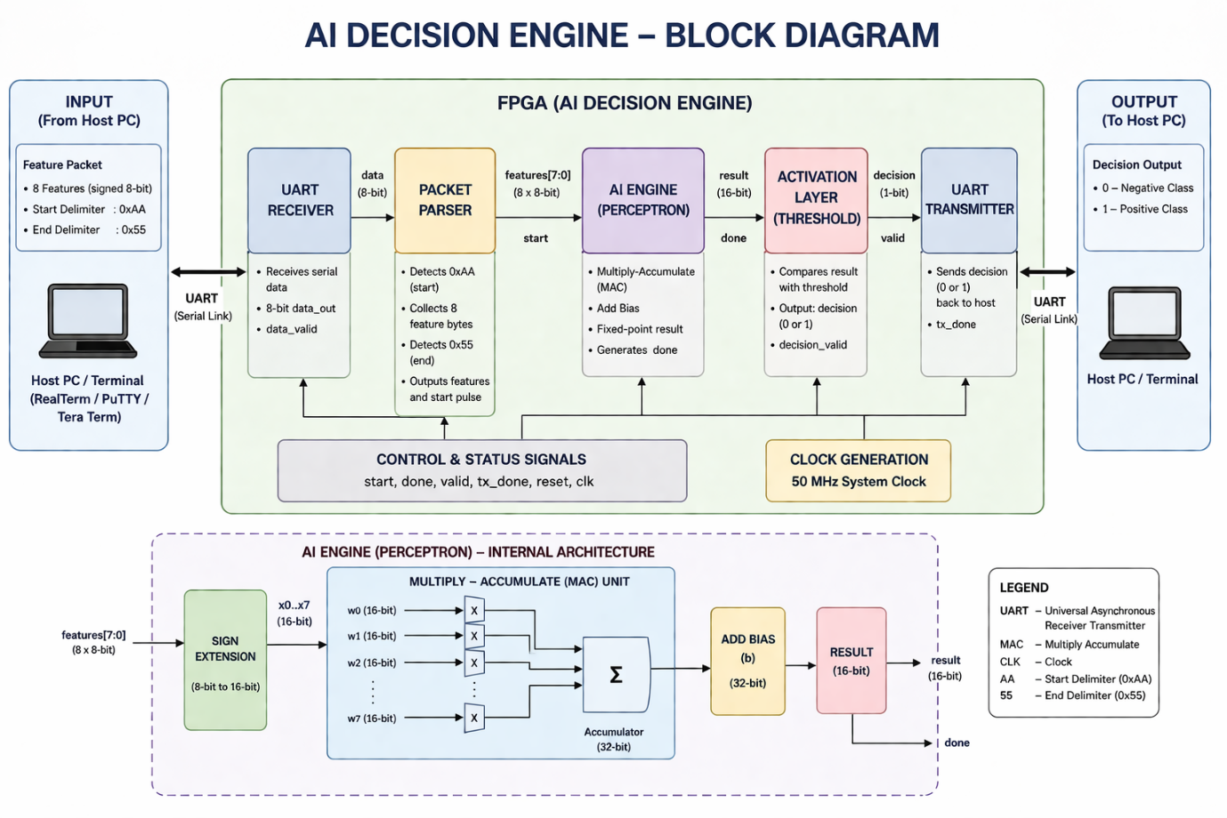
Fig. 2.1: AI Decision Engine – Block Diagram

2.2 DATA FLOW EXPLANATION
The data flow of the proposed AI decision engine describes how input data moves through different modules of the system to produce the final output. The process begins with the acquisition of input features, which are either provided through a UART interface or directly from a simulation testbench. These inputs are received in serial or parallel form and stored in internal feature registers for further processing.
Once the input features are available, they are sequentially or simultaneously fed into the computational block. Each feature is paired with a corresponding weight stored within the system. The Multiply-Accumulate (MAC) unit performs multiplication between each input feature and its respective weight. The results of these multiplications are then accumulated to produce a single aggregated value representing the weighted sum.
This accumulated value is passed to the activation function block. The activation function evaluates the result based on a predefined threshold condition and generates the final output. Typically, the output is binary in nature, representing a decision outcome based on the input data.
The entire process is controlled by a Finite State Machine (FSM), which ensures proper sequencing of operations. The FSM manages states such as input loading, computation, and output generation, ensuring synchronization between modules. Data transitions from one stage to another in a controlled and efficient manner, minimizing delays and ensuring correct functionality.
Finally, the output is made available either internally for further processing or externally for observation. This structured data flow ensures efficient utilization of hardware resources and enables real-time decision-making in FPGA-based systems.
2.3 DESIGN CONSIDERATIONS
2.3.1 POWER OPTIMIZATION
Power efficiency is a key consideration in the design of the proposed AI decision engine. Since the target platform is FPGA-based systems, minimizing power consumption is essential for embedded and portable applications. The use of fixed-point arithmetic instead of floating-point significantly reduces switching activity and hardware complexity, thereby lowering power usage. Additionally, the modular design approach helps in activating only the required components during operation, further improving energy efficiency.
2.3.2 SCALABILITY
Scalability is achieved through the use of a parameterized design methodology. The system is designed in such a way that parameters such as the number of input features and data width can be easily modified without redesigning the entire architecture. This flexibility allows the system to adapt to different application requirements. For example, the number of features can be increased for more complex models or reduced for simpler tasks, making the design highly reusable.
2.3.3 MODULARITY
The system follows a modular design approach, where each functional block is implemented as an independent module. These modules include input handling, weight storage, computational blocks, control logic, and communication interfaces. Modularity simplifies the design process, making it easier to debug, test, and maintain individual components. It also allows for future enhancements, where new modules can be added or existing ones can be modified without affecting the entire system.

CHAPTER 3

IMPLEMENTATION
3.1 INPUT FEATURE DESIGN
The input feature design defines how external data is structured, represented, and fed into the AI decision engine. In this project, the system is designed to handle multiple input features, with the current implementation supporting eight features. Each feature represents a numerical value that contributes to the decision-making process of the Perceptron model.

Feature Index | Description  (example: recognition of character ‘A’) | Bit Width
f0 | Input Feature 0 (vertical) | 8-bit
f1 | Input Feature 1 (left stroke) | 8-bit
f2 | Input Feature 2 (right stroke) | 8-bit
f3 | Input Feature 3 (top) | 8-bit
f4 | Input Feature 4 (middle bar) | 8-bit
f5 | Input Feature 5 (symmetry) | 8-bit
f6 | Input Feature 6 (edges) | 8-bit
f7 | Input Feature 7 (thickness) | 8-bit
Table 3.1: Input features
The design follows a parameterized approach, where the number of features is not hardcoded but defined using parameters. This allows scalability, enabling the system to adapt to different applications by simply modifying parameter values. Each input feature is assigned a fixed bit width and stored in dedicated registers before being processed.
The input features are provided either through a UART interface or directly through a testbench during simulation. Proper synchronization is maintained to ensure correct data loading before computation begins. This design ensures flexibility, efficient storage, and seamless integration with the computational blocks.
3.2 FIXED-POINT REPRESENTATION
Fixed-point representation is used in this design to achieve efficient hardware implementation. Unlike floating-point arithmetic, which requires complex circuitry, fixed-point arithmetic uses simpler integer-based operations, reducing hardware utilization and power consumption.
Each input feature and weight are represented using a fixed number of bits, typically following a Q-format representation. In this format, a portion of the bits represents the integer part, while the remaining bits represent the fractional part. This allows representation of real numbers while maintaining computational simplicity.
Fixed-point numbers are commonly represented using Q-format notation, which defines how many bits are allocated for the integer and fractional parts.
A Q-format is generally written as Qm.n, where:
m → number of bits for integer part (including sign)
n → number of bits for fractional part
For example, in a Q3.4 format (8-bit total):
- 1 bit → sign
- 3 bits → integer part
- 4 bits → fractional part
Consider the decimal number 5.25
- Step 1: Convert integer part (5) → Binary = 0101
- Step 2: Convert fractional part (0.25):
    - 0.25 × 2 = 0.5 → 0
    - 0.5 × 2 = 1.0 → 1
- So fractional = .01
- Final fixed-point (Q3.4) → 0101.0100
3.3 AI MODEL REPRESENTATION
The AI model used in this project is a single-layer Perceptron, which is one of the simplest forms of neural networks. It performs a weighted sum of input features followed by an activation function to produce an output decision.
Mathematically, the Perceptron operation can be expressed as:
$$Y=∑(X_{i}⋅W_{i})+b$$
where:
- $X_{i}$ = input features
- $W_{i}$ = corresponding weights
- $b$ = bias term
The computed value is passed through an activation function, typically a threshold function, to produce a binary output. This makes the model suitable for classification-type decision-making.

Step-by-Step Process:
- Input Stage
All input features $X_{0}, X_{1}, …X_{n-1}$ are provided to the system.
- Multiplication
Each input is multiplied with its corresponding weight:
$$X_{0}W_{0}, X_{1}W_{1}, …X_{n-1}W_{n-1}$$
- Accumulation (Summation)
All products are added together:
$${S=(X}_{0}W_{0}+ X_{1}W_{1}+ …{+ X}_{n-1}W_{n-1})$$
- Add Bias
$$S=S+b$$
- Activation Function
A threshold function is applied:
$$Y=\left\{\begin{aligned}0, if &S<0 \\ \\ 1, if &S≥0\end{aligned}\right.$$
Perceptron Diagram:

$X_{0} × { W}_{0}$

$X_{1} × W_{1}$
$[SUM]$ + [Bias] Activation Output (Y)
$X_{2} × W_{2}$
…
$X_{n-1} × W_{n-1}$
Fig. 3.1: Simple Perceptron Diagram

3.4 WEIGHT STORAGE & INITIALIZATION
Weights are critical parameters that determine the behaviour of the Perceptron model. In this design, weights are predefined and stored within the system using registers or parameterized constants. These weights are represented in fixed-point format to match the input representation.
During simulation, weights are initialized at the beginning of execution. This initialization ensures that the system performs correct computations. The design allows easy modification of weights, making it flexible for testing different scenarios.
Efficient storage of weights is important to ensure quick access during computation. The system is designed such that weights are readily available to the MAC unit without introducing delays.

Feature Index | Weight (Char ‘A’) | Weight (Digit ‘1’)
$$w0$$ | $$8’sd6$$ | $$8’sd12$$
$$w1$$ | $$8’sd8$$ | $$-8’sd6$$
$$w2$$ | $$8’sd8$$ | $$-8’sd6$$
$$w3$$ | $$8’sd5$$ | $$8’sd3$$
$$w4$$ | $$8’sd12$$ | $$8’sd2$$
$$w5$$ | $$8’sd6$$ | $$-8’sd5$$
$$w6$$ | $$8’sd4$$ | $$8’sd4$$
$$w7$$ | $$8’sd5$$ | $$8’sd6$$
Bias | $$-8^{'}sd25$$ | $$-8^{'}sd20$$

Table 3.2: Sample Trained Weights Used in Design

3.5 COMPUTATIONAL BLOCKS
The computational block forms the core of the AI decision engine. It consists primarily of a Multiply-Accumulate (MAC) unit, which performs the main arithmetic operations required for the Perceptron model.
Each input feature is multiplied by its corresponding weight using a multiplier. The results are then accumulated using an adder to produce a final sum. This operation may be performed sequentially or in parallel depending on the design.
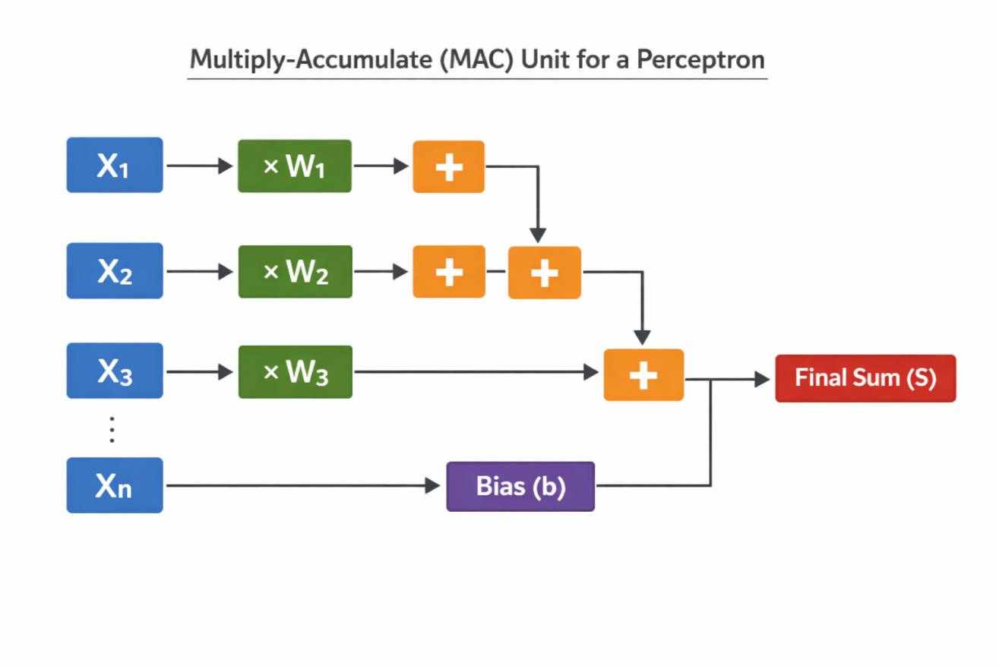
After accumulation, the result is passed through an activation function, which determines the output based on a threshold. The computational block is optimized for speed and efficiency, ensuring minimal delay and reduced hardware usage.

Fig. 3.2: MAC (Multiply-Accumulate) Block Diagram

3.6 CONTROL LOGIC (FSM)
The control logic is implemented using a Finite State Machine (FSM), which governs the sequence of operations in the system. The FSM ensures that each stage of processing occurs in the correct order and at the right time.
Typical states include:
- Idle state
- Input loading state
- Computation state
- Output generation state
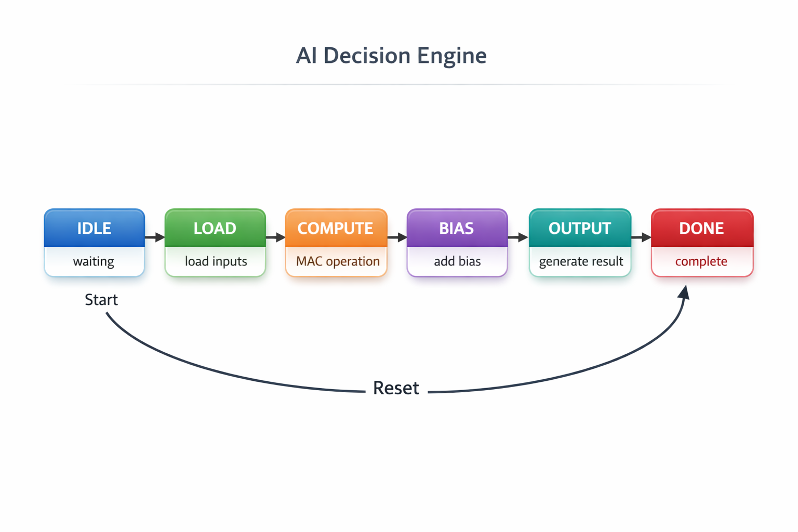
The FSM transitions between these states based on control signals and conditions. This structured approach ensures synchronization between modules and prevents data corruption.
Fig. 3.3: FSM State Diagram

FSM State Descriptions
IDLE State:
The system remains in the IDLE state while waiting for the start signal. No computation is performed in this state, and all modules remain inactive. Once a valid start signal is received, the FSM transitions to the LOAD state.
LOAD State:
In the LOAD state, input features are received and stored into internal registers. This ensures that all required data is ready before computation begins. After successful data loading, the system moves to the COMPUTE state.

COMPUTE State:
During the COMPUTE state, the Multiply-Accumulate (MAC) operation is performed. Each input feature is multiplied with its corresponding weight, and the results are summed. This state forms the core computation stage of the system.
BIAS State:
In this state, the bias value is added to the accumulated sum obtained from the MAC operation. This step adjusts the decision boundary of the Perceptron model. After bias addition, the system proceeds to the OUTPUT state.
OUTPUT State:
The OUTPUT state generates the final result by applying the activation function to the computed value. The processed output is made available for further use or transmission. Once the output is ready, the FSM transitions to the DONE state.
DONE State:
The DONE state indicates that the computation process is complete. The system holds the output stable and waits for a reset or new start signal. Upon reset, the FSM returns to the IDLE state for the next operation cycle.

The Finite State Machine (FSM) controls the sequential execution of the AI decision engine. It ensures that operations such as input loading, computation, bias addition, and output generation occur in a well-defined order. Each state represents a specific stage in processing, and transitions occur based on control signals and clock cycles.

Current State | Condition | Next State | Operation
IDLE | Start = 1 | LOAD | Wait for input
LOAD | Data ready | COMPUTE | Load features
COMPUTE | MAC complete | BIAS | Perform multiplication
BIAS | Done | OUTPUT | Add bias
OUTPUT | Output ready | DONE | Generate result
DONE | Reset/Next | IDLE | Ready for next input
Table 3.3: State Transition Table

3.7 UART INTERFACE
The UART interface enables communication between the external environment and the hardware system. It allows input features to be transmitted serially into the system.
The UART receiver module captures serial data and converts it into parallel format. This data is then stored in feature registers for further processing. The interface operates based on standard UART protocols, including start bit, data bits, and stop bit.
This module enables real-time data input and enhances the practical usability of the system in embedded applications.
Baud Rate Explanation:
Baud rate refers to the number of signal changes (bits transmitted) per second in a communication channel. In UART communication, baud rate determines how fast data is transmitted between the transmitter and receiver. It is typically measured in bits per second (bps).
For example, a baud rate of 9600 bps means that 9600 bits are transmitted every second. Both the transmitting and receiving devices must be configured with the same baud rate to ensure accurate data communication. If there is a mismatch in baud rates, it can lead to data corruption or communication failure.
In UART, each bit occupies a fixed time duration depending on the baud rate. The time period of one bit can be calculated as:
$$Bit Duration=\frac{1}{Baud Rate}$$
For instance, at 9600 bps:
$$Bit Duration=\frac{1}{9600}≈104.16 μs$$
This means each bit is transmitted for approximately $104 microseconds$.

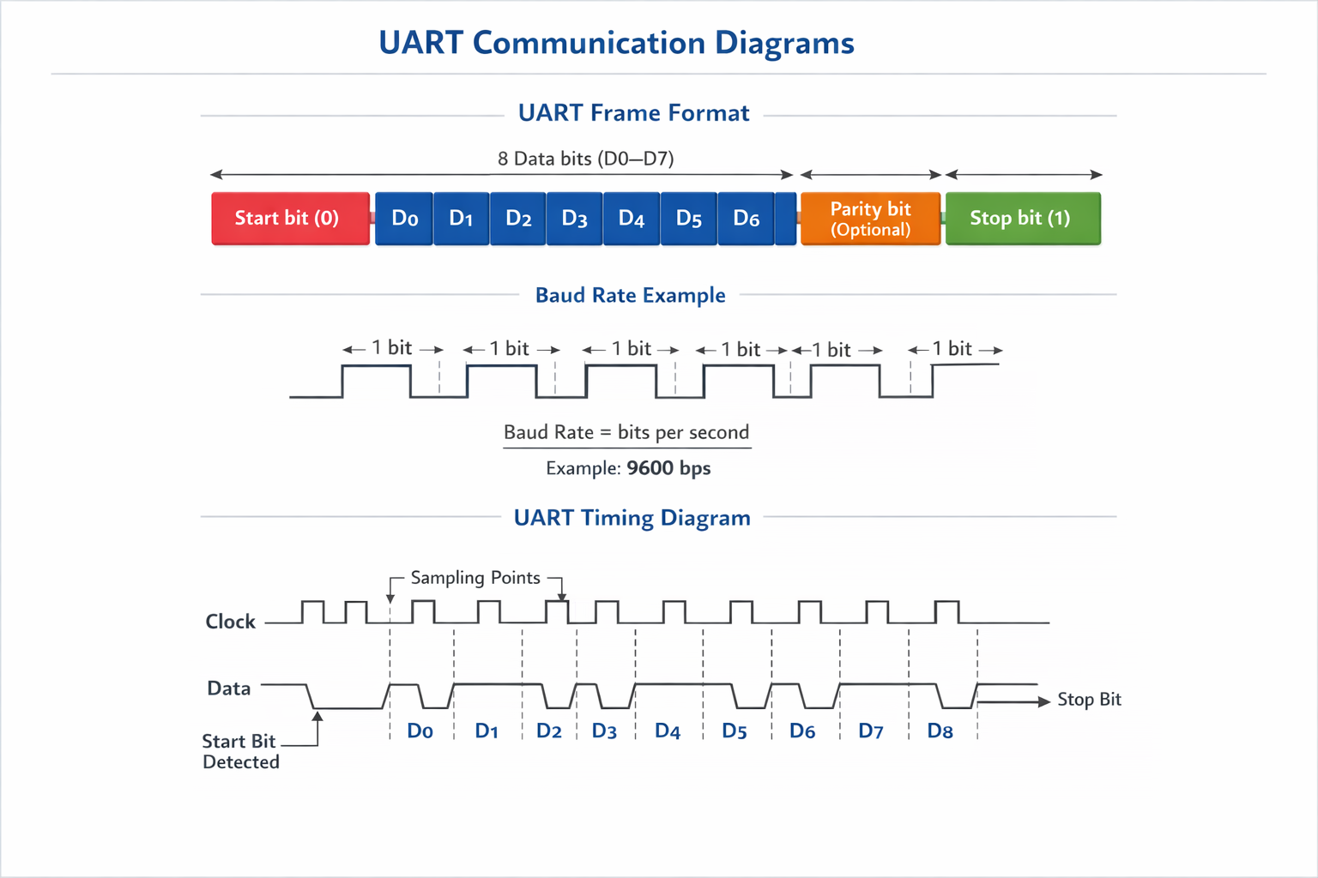
Fig. 3.4: UART frame format diagram

3.8 TOP MODULE INTEGRATION
The top module integrates all individual components into a single cohesive system. It connects input interfaces, computational blocks, control logic, and output modules.
Signal routing is carefully designed to ensure proper data flow between modules. Synchronization is maintained using clock signals and control logic. The modular approach allows easy debugging and future scalability.
The top module represents the complete implementation of the AI decision engine and serves as the main unit for simulation and synthesis.

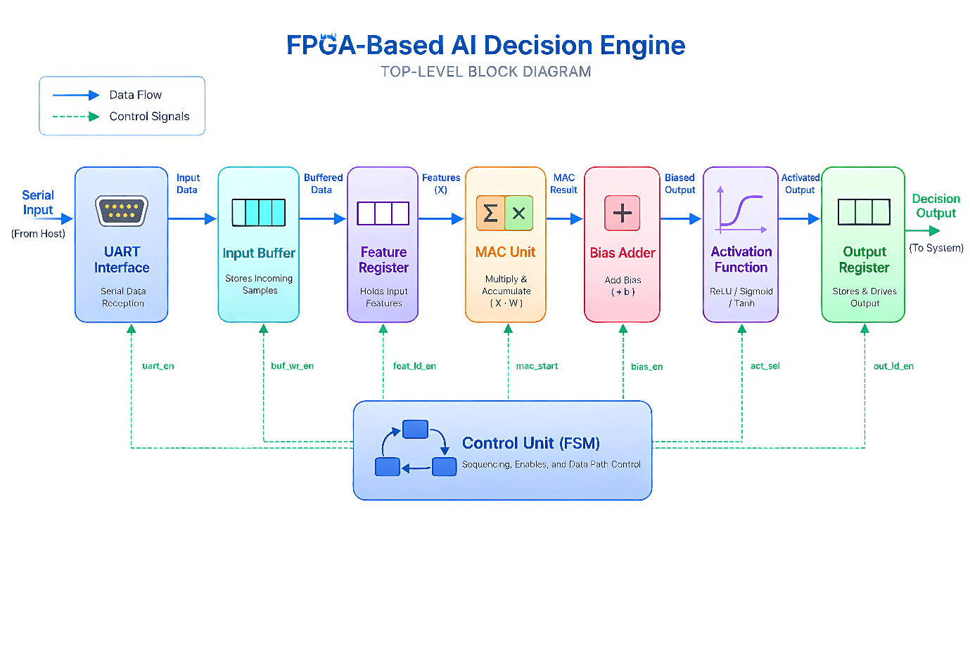

Fig. 3.5: Top Level block diagram

CHAPTER 4

FUNCTIONAL SIMULATION
4.1 SIMULATION SETUP
The functional simulation of the proposed AI decision engine is carried out to verify the correctness of the design before hardware implementation. Simulation is performed using industry-standard tools such as Xilinx Vivado/ModelSim, which support Verilog HDL-based design verification. The purpose of simulation is to analyse the behaviour of the system under different input conditions and ensure that all modules operate as expected.
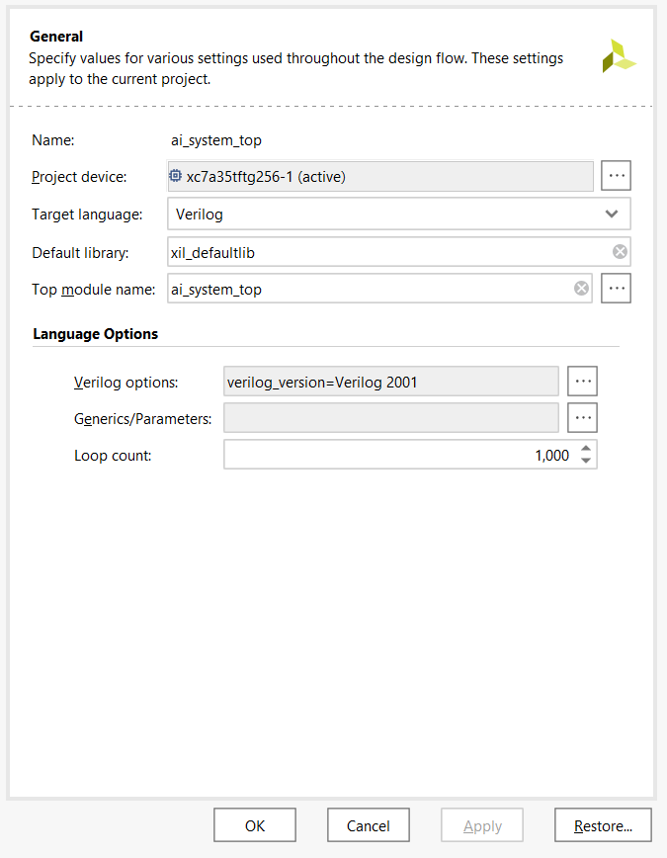
The simulation environment consists of the design modules, a testbench, and waveform analysis tools. The design is compiled, and necessary constraints such as clock signals and timing parameters are defined. A clock signal is generated to synchronize the operation of all sequential elements within the system.
Fig. 4.1: Project Setup
Input stimuli are provided through the testbench, which mimics real-time input conditions. These inputs include feature values and control signals required to trigger the operation of the AI engine. The simulation runs for a predefined duration, allowing observation of internal signals and outputs.
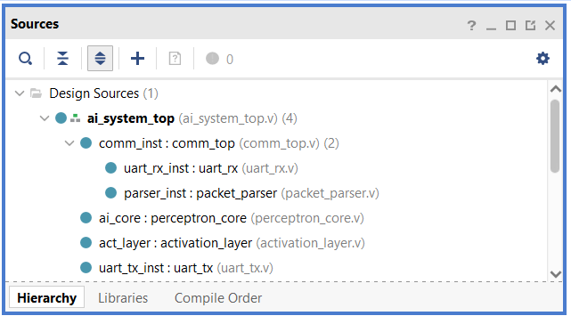
Waveforms generated during simulation are analysed to verify correct data flow, timing relationships, and functional accuracy. Any inconsistencies observed are debugged and corrected before proceeding further.
Fig. 4.2: Design source files included
Clock Generation Explanation:
The clock signal is a periodic square wave used to synchronize all operations in the system. It is generated in the testbench using an always block that toggles the clock at a fixed interval. Each rising edge of the clock triggers state transitions in the FSM and updates data in registers. The stability and frequency of the clock directly affect the timing and performance of the system.
Fig. 4.3: Clock toggling
4.2 TESTBENCH DESIGN:
The testbench is a critical component used to verify the functionality of the hardware design. It acts as a virtual environment that provides input stimuli to the design under test (DUT) and observes the corresponding outputs.
In this project, the testbench is written in Verilog and is designed to simulate real-time input conditions. It initializes input features, control signals, and clock/reset conditions. The testbench feeds input data either sequentially or in parallel, depending on the design requirements.

Test Case | Input Features $(X0–X7)$ | Expected Output | Actual Output | Status
TC1 | $$6, 8, 8, 5, 10, 7, 4, 5$$ | 1 | 1 | Pass
TC2 | $$12, 2, 2, 3, 2, 1, 3, 2$$ | 0 | 0 | Pass
TC3 | 1, 1, 1, 1, 1, 1, 1, 1 | 0 | 1 | Fail
TC4 | Mixed values | 0 | 0 | Pass

Table 4.1: Test cases table
Different test cases are applied to validate the system under various conditions. These include normal input values, boundary conditions, and edge cases. The output generated by the system is monitored and compared with expected results to ensure correctness.
The testbench also includes delay mechanisms to simulate realistic timing behaviour. This helps in verifying synchronization and proper sequencing of operations controlled by the FSM.
Expected vs Actual Output:
The expected output is calculated manually or using a software reference model based on the Perceptron equation. It represents the ideal result for a given set of input features and weights. The actual output is obtained from the simulation waveform generated by the hardware design.
By comparing the expected and actual outputs, the correctness of the design is verified. A match between both confirms that the MAC unit, bias addition, and activation function are functioning properly. Any mismatch indicates errors in implementation, which are further analysed and corrected.
4.3 SIMULATION RESULTS
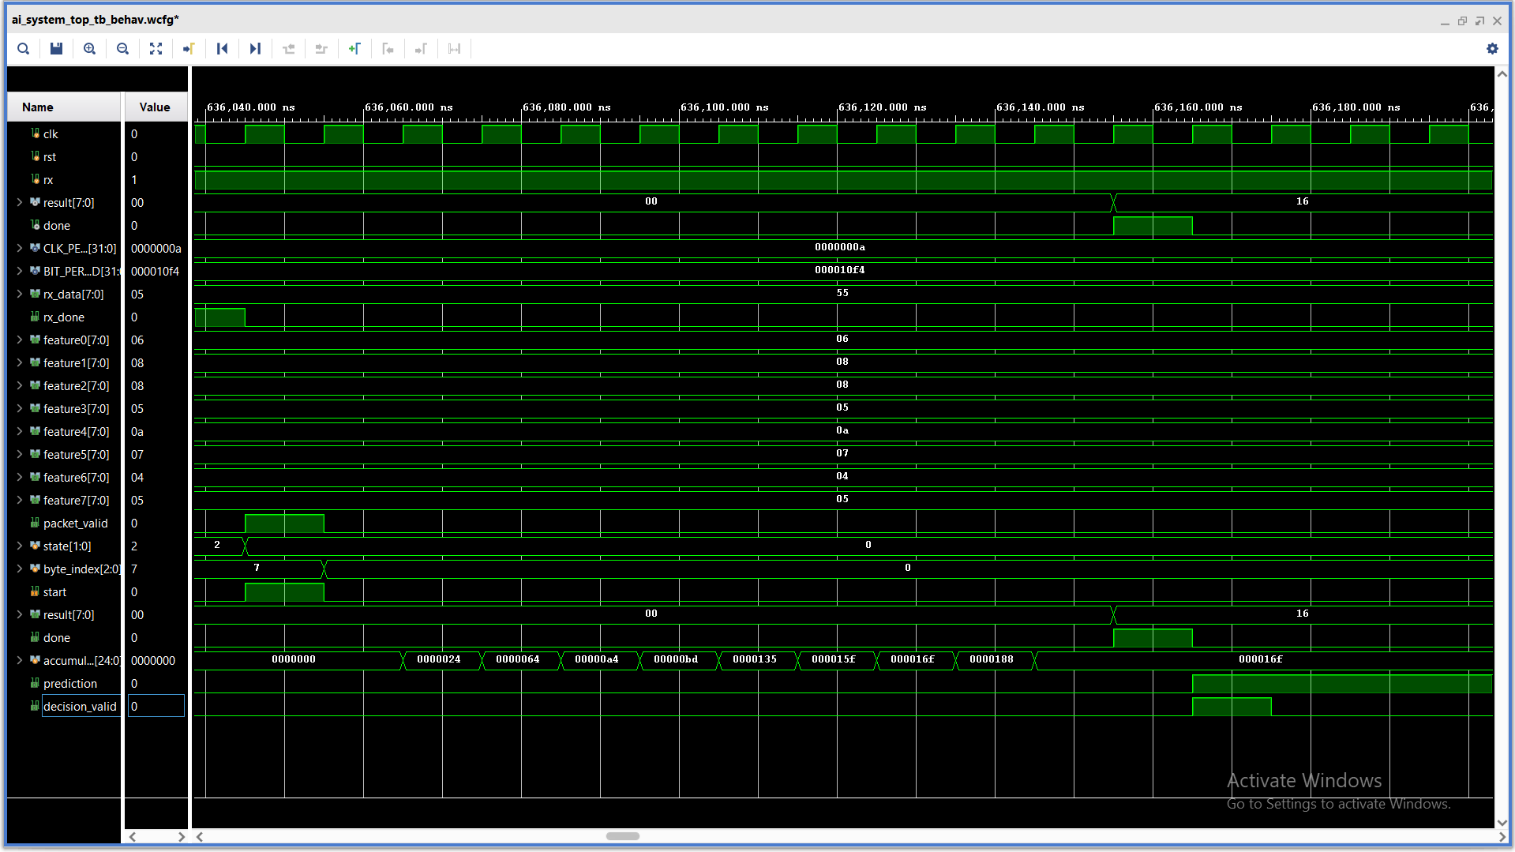
The simulation results demonstrate the functional correctness of the AI decision engine. Waveforms generated during simulation provide a visual representation of signal transitions over time.

Fig. 4.4: Simulation Top level waveform
Key signals such as input features, weights, intermediate MAC results, FSM states, and final output are analysed. The waveforms show that input data is correctly loaded into registers, processed through the MAC unit, and passed through the activation function to generate the expected output.
The FSM operation is also verified through waveform analysis, ensuring that state transitions occur in the correct sequence. Timing relationships between signals are observed to confirm proper synchronization.
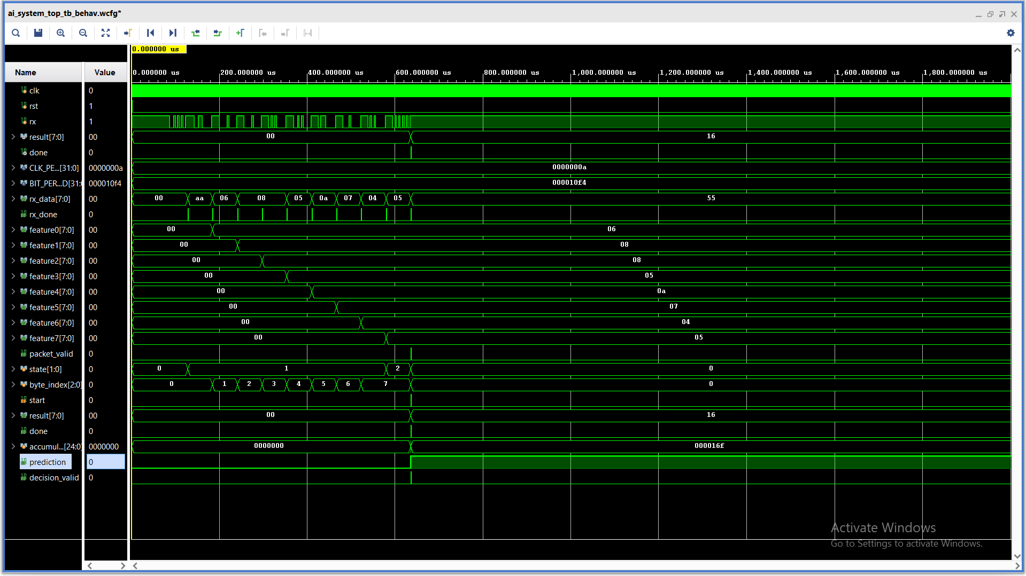
The results confirm that the system performs the Perceptron-based computation accurately and produces correct outputs for different input conditions. This validates the effectiveness of the design.

Fig. 4.5: Simulation State waveform
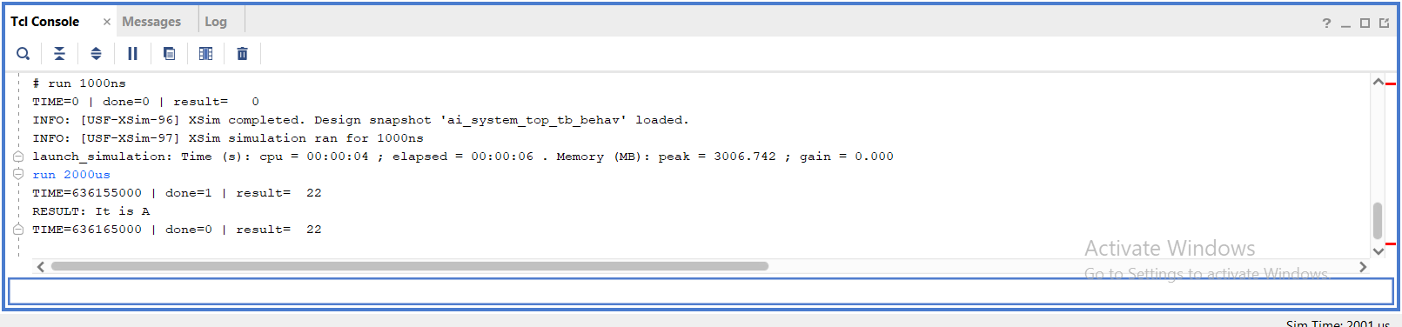
The waveform illustrates the FSM state transitions occurring in a sequential manner, driven by the clock signal. Each transition corresponds to a specific stage of operation such as data loading, computation, and output generation. The correct progression of states verifies that the control logic is functioning as intended.

Fig. 4.6: Simulation terminal output

CHAPTER 5

ANALYSIS
5.1 TIMING ANALYSIS
Timing analysis is performed to evaluate whether the designed system meets the required timing constraints for reliable operation. In FPGA-based designs, timing plays a crucial role in determining the maximum operating frequency and overall system performance.
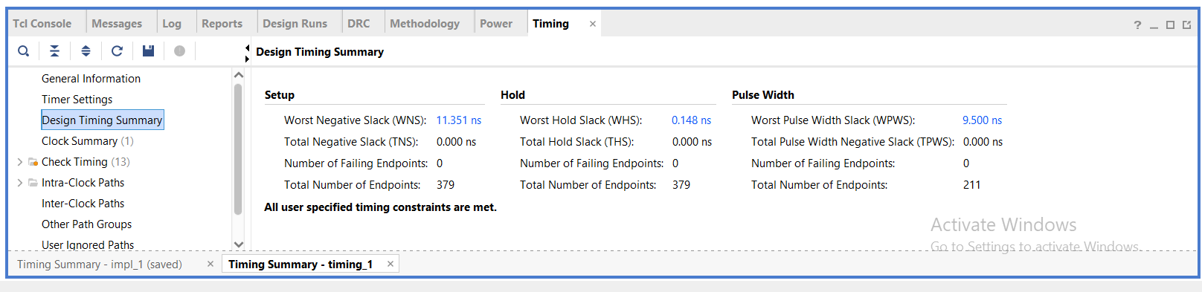
The timing report generated from Vivado provides important parameters such as Worst Negative Slack (WNS), Total Negative Slack (TNS), and maximum path delay. WNS indicates the worst-case timing violation in the design, while TNS represents the cumulative timing violations across all paths. A positive slack value indicates that the design meets timing requirements, whereas negative slack indicates timing failure.

Fig. 5.1: Timing report
In this project, timing analysis is carried out after synthesis and implementation. The results show that the design meets the required timing constraints under the given conditions. Any minor violations observed are analysed and resolved through optimization techniques such as improving logic paths and reducing combinational delays.
5.2 RESOURCE UTILIZATION ANALYSIS
Resource utilization analysis provides insight into how efficiently the FPGA resources are used by the design. The Vivado utilization report includes details about logic elements such as Look-Up Tables (LUTs), Flip-Flops (FFs), Block RAM (BRAM), and DSP slices.
The proposed AI decision engine is designed with a focus on low resource utilization. The use of fixed-point arithmetic reduces the need for complex hardware blocks, thereby minimizing resource consumption. The modular design approach also ensures that only necessary components are utilized.
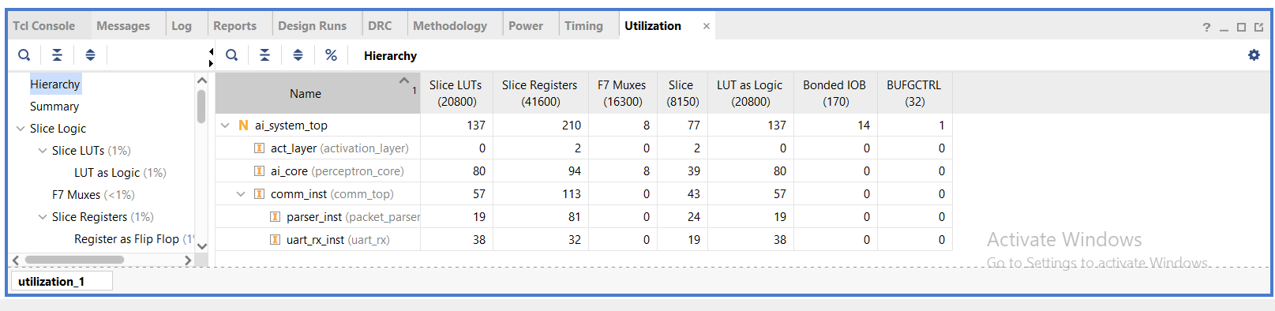
Fig. 5.2: Utilization report
The utilization report indicates that the design occupies a small percentage of available FPGA resources, making it suitable for deployment even on low-cost FPGA devices. Efficient resource usage also contributes to reduced power consumption and improved scalability.
5.3 POWER ANALYSIS
Power analysis is an important aspect of FPGA-based design, especially for low-power applications. Although actual power measurement requires hardware implementation, an estimated analysis can be performed based on design characteristics.
The use of fixed-point arithmetic significantly reduces switching activity and computational complexity, leading to lower dynamic power consumption. Additionally, the modular design ensures that only active components consume power at any given time.
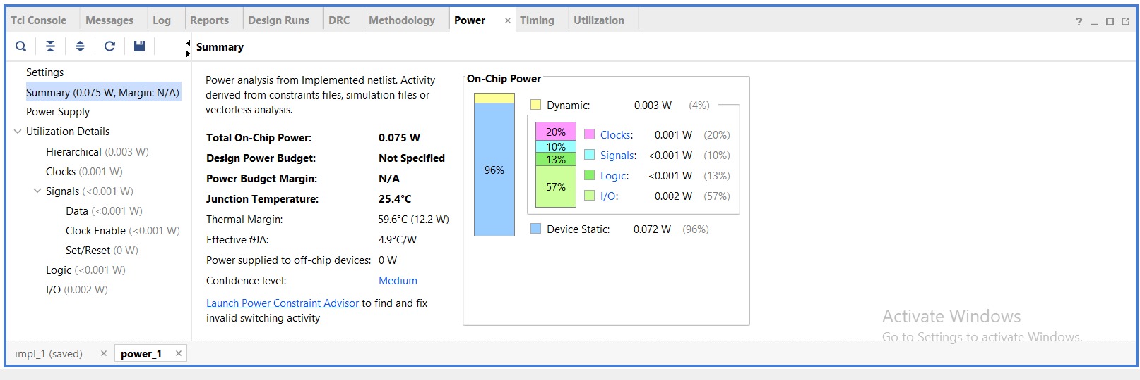
Fig. 5.3: Power report
Clock-driven sequential logic is optimized to minimize unnecessary transitions, further improving power efficiency. The absence of floating-point units and complex control logic also contributes to reduced power usage.
Overall, the design demonstrates characteristics suitable for low-power applications, aligning with the objectives of the project.
5.4 PERFORMANCE DISCUSSION
The performance of the system is analysed in terms of speed, latency, and efficiency. The latency of the system depends on the number of clock cycles required for input loading, computation, and output generation.
The use of a MAC unit enables efficient computation of weighted sums, while fixed-point arithmetic reduces computational overhead. The system demonstrates fast response time suitable for real-time decision-making applications.
Additionally, the design is optimized for FPGA implementation, ensuring efficient utilization of hardware resources and low power consumption. These factors contribute to the overall performance of the system.

5.5 DISCUSSION ON DESIGN EFFICIENCY
The proposed design demonstrates efficient utilization of hardware resources while maintaining functional accuracy. The parameterized architecture allows flexibility in scaling the system, making it adaptable to different applications.
The use of fixed-point arithmetic significantly reduces complexity and power consumption compared to floating-point implementations. The modular design approach improves maintainability and allows easy integration of additional features in the future.
Although the system is simple, it effectively demonstrates the feasibility of implementing AI models in hardware for low-power applications.

CHAPTER 6

LIMITATION AND FUTURE WORKS
6.1 LIMITATIONS OF THE PROPOSED SYSTEM
Although the proposed AI decision engine demonstrates successful implementation and simulation, it has certain limitations that must be acknowledged. One of the primary limitations is the absence of physical FPGA implementation. The design has been verified only through functional simulation, and real-time hardware validation could reveal additional challenges such as timing issues and power variations.
Another limitation is the use of a simple Perceptron model, which restricts the system to basic decision-making tasks. More complex AI problems typically require multi-layer neural networks, which are not implemented in this design. Additionally, the system uses a limited number of input features, which may not be sufficient for handling complex datasets.
The use of fixed-point arithmetic, while efficient, introduces quantization errors that may slightly affect accuracy. Furthermore, weights are predefined and not dynamically trained within the hardware, limiting adaptability. The UART interface, although functional, may also limit data transfer speed for large-scale applications.
6.2 FUTURE WORK
The proposed system provides a strong foundation for further enhancements and improvements. One of the key future extensions is the implementation of the design on an actual FPGA board. This would enable real-time validation and allow detailed analysis of timing, power consumption, and hardware performance.
Another important improvement is extending the AI model to support multi-layer neural networks (Deep Learning). This would significantly enhance the capability of the system to handle complex classification problems. Additionally, implementing on-chip training or adaptive weight updating mechanisms could improve system flexibility.
The design can also be enhanced by increasing the number of input features and improving precision through optimized fixed-point formats. Advanced communication interfaces such as SPI or high-speed protocols can be integrated to improve data transfer efficiency.
Power optimization techniques such as clock gating and pipelining can be incorporated to further reduce energy consumption and improve performance. Integration with real-world sensors and IoT devices can make the system suitable for practical embedded applications.

CHAPTER 7

CONCLUSION
This project successfully presents the design and simulation of a Low Power AI Decision Engine using Verilog HDL, targeting FPGA-based implementation. The system is based on a single-layer Perceptron model, which performs decision-making using weighted input features and an activation function. The design adopts a parameterized approach, allowing flexibility in the number of input features and making the system scalable for different applications.
The architecture is designed in a modular manner, incorporating essential components such as input feature registers, weight storage, a Multiply-Accumulate (MAC) unit, control logic using a Finite State Machine (FSM), and a UART interface for communication.
The system has been thoroughly verified through functional simulation. Additionally, timing and resource utilization analysis indicate that the design is efficient and suitable for FPGA deployment.
Although the implementation is limited to simulation, the design is fully synthesizable and ready for hardware realization. The project effectively demonstrates the feasibility of implementing AI models in hardware with low power consumption and efficient resource usage.
In conclusion, this work provides a strong foundation for developing hardware-based AI systems and highlights the potential of FPGA platforms for low-power intelligent applications. The design can be further extended and optimized to support more complex AI models and real-time applications.

REFERENCES
[1] D. Patterson and J. Hennessy, Computer Organization and Design: The Hardware/Software Interface, 5th ed., Morgan Kaufmann, 2013.
[2] Xilinx Inc., “Vivado Design Suite User Guide,” 2023.
[3] Xilinx Inc., “7 Series FPGAs Data Sheet,” 2022.
[4] M. Mano and M. Ciletti, Digital Design, 5th ed., Pearson, 2013.
[5] N. Weste and D. Harris, CMOS VLSI Design: A Circuits and Systems Perspective, 4th ed., Pearson, 2011.
[6] A. K. Jain, “Artificial Neural Networks: A Tutorial,” Computer, vol. 29, no. 3, pp. 31–44, 1996.

